1.
#include <stdio.h>
float add(float a, float b)
{
return a + b;
}
float sub(float a, float b)
{
return a - b;}
float mul(float a, float b)
{
return a * b;
}
float divi(float a, float b){
{
if(b!=0){
return a/b;}
else
{
printf("error:divison by zero!\n");
return 0;
}
}
}
int main() {
float x, y,c;
printf("Enter two numbers: ");
scanf("%f %f", &x, &y);
c=add(x,y);
printf("Addition = %.2f\n",c);
printf("Subtraction = %.2f\n",sub(x,y) );
printf("Multiplication = %.2f\n",mul(x,y) );
printf("Division = %.2f\n", divi(x, y));
return 0;
}
Output:
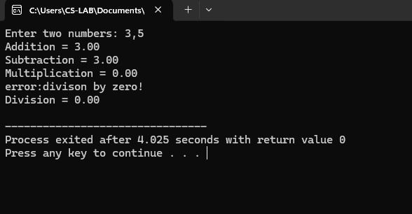
2. #include <stdio.h>
int factorial(int n) {
int f= 1;
for (int i =1; i <=n; i++)
f *= i;
return f;
}
int main() {
int num;
printf("Enter a number: ");
scanf("%d", &num);
printf("Factorial of %d = %d\n", num, factorial(num));
return 0;
}
Output
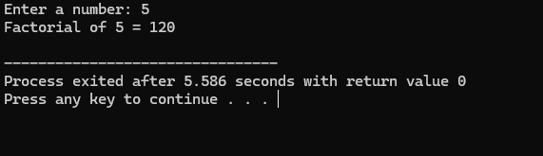
3.
#include <stdio.h>
void fibonacci(int n) {
int a = 0, b = 1, c;
printf("Fibonacci Series: %d %d ", a, b);
for (int i = 2; i <n; i++) {
}
c= a+b;
printf("%d ", c);
a = b;
b = c;
}
int main() {
int n;
printf("Enter number of terms: ");
scanf("%d", &n);
fibonacci(n);
return 0;
}
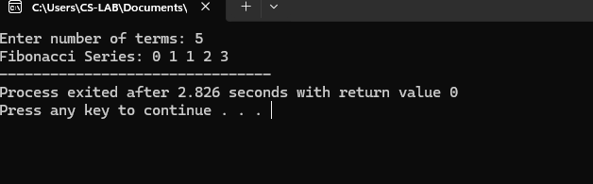
4.
#include <stdio.h>
int factorial(int n) {
if (n==0)
return 1;
else
return n * factorial(n - 1);
}
int main() {
int num;
printf("Enter a number: ");
scanf("%d", &num);
printf("Factorial of %d = %d\n", num, factorial(num));
return 0;
}
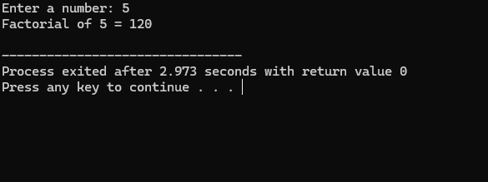
5.
#include <stdio.h>
int fibonacci(int n) {
if (n ==0) return 0;
else if (n== 1) return 1;
else return fibonacci(n - 1) + fibonacci(n - 2);
}
int main(){
int n;
printf("Enter number of terms: ");
scanf("%d", &n);
printf("Fibonacci Series: ");
for (int i = 0; i <n; i++)
printf("%d ", fibonacci(i));
return 0;
}
6.
#include <stdio.h>
void swapByValue(int x, int y) {
int temp;
temp = x;
x = y;
y = temp;
printf("Inside swapByValue function:\n");
printf("x = %d, y = %d\n", x, y);
}
int main() {
int a = 10, b = 20;
printf("Before calling swapByValue:\n");
printf("a = %d, b = %d\n", a, b);
swapByValue(a, b); // Passing copies of a and b
printf("After calling swapByValue:\n");
printf("a = %d, b = %d\n", a, b); // a and b remain unchanged
return 0;
}
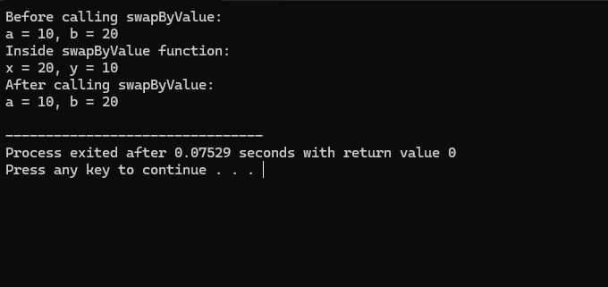
7.
#include <stdio.h>
#include <string.h>
#include<stdio.h>
int main() {
FILE *fpin, *fpout;
char buffer[256];
const char *old_text = "line written";
const char *new_text = "updated content";

fpin = fopen("example.txt", "r");
fpout = fopen("temp.txt", "w"); // Create a temporary file for updated content

if (fpin == NULL || fpout == NULL) {
printf("Error opening files!\n");
return 1;
}

while (fgets(buffer, sizeof(buffer), fpin) != NULL) {
if (strstr(buffer, old_text) != NULL) {
// Replace old_text with new_text
// This is a simplified replacement; for more complex cases, consider string manipulation functions
fprintf(fpout, "%s\n", new_text);
} else {
fputs(buffer, fpout);
}
}

fclose(fpin);
fclose(fpout);

remove("example.txt"); // Delete the original file
rename("temp.txt", "example.txt"); // Rename the temporary file to the original name

printf("File updated successfully.\n");
return 0;
}
